Table of Contents

Hospital Appointment System

Section 1: - Analysis 1
Background to and Identification of the Problem 2
Identification of the Prospective Users 3
Interview Notes 4
Questionnaires 8
Examining Existing Documents 14
Description of Current System 17
Analysis of All Documentation 17
How the Existing System is Run 18
Problems in the Existing System 19
Identification of the User(s) Needs and Acceptable Limitations 20
Features of the New System 20
Agreed and Acceptable Limitations of the New System 22
Data Sources and Destinations 23
Data Volumes 25
Analysis Data Dictionary 26
Data Flow Diagrams of the Existing System 29
Entity Relationship Model and Entity Descriptions 30
Realistic Appraisal of the Feasibility of Potential Solutions 31
Improving the Existing Manual System 31
Buying a Package Specifically Written for an Appointment System 32
Customizing a General Purpose Database 33
Writing a Program Using Visual Basic 34
Writing a Program that is a Combination of Access and Visual Basic 35
Potential Solutions Summary 36
Justification of a Chosen System 37
General and Specific Objectives 38

Background to and the Identification of the Problem

“Patient Choice Centre” is part of the NHS and for East Lancashire patients, this is located in Nelson. This organization provides patients with the means of setting up appointments through the use of either a written letter, phone or online.
“Patient Choice Centre” utilizes the “Choose and Book” booking system which is also used nationwide. “Choose and Book” is a service that lets you choose your hospital or clinic and book your first appointment. When the GP off a patient agrees that they need an appointment, the patient is free to choose which hospital or clinic they want to go to and can choose the date and time of this appointment. Patients can also check the status of their referral as well as change or cancel their appointments over the phone or internet.
Through this organization, patients are free to choose any hospital in England funded by the NHS which includes some independent hospitals as well.
The appointment system used by this organization produces a few problems.
The problems with the current appointment system include:
- Conflicting appointments
- Tediousness of producing one letter for an appointment at a time
- Lack of a search function

I will be looking at these problems and creating a new system with the desire to eliminate these problems and add more features and functionality to the appointment system.

Identification of the Prospective User(s)

Here I will list and identify the users that will be using this new appointment system. Below is a description of their current job and experience with the system. Also listed is their ICT skills and possible future training that they may require.

Zaman Ghani –
Zaman Ghani is one of the many administrators that are responsible for the appointment system. His job is to confirm the details of patients who have appointments. Another job is to both book the patients appointments and cancel them. He also has the responsibility for making amendments that are needed if the data is not accurate in the appointments as well as having the responsibility of sending out the appropriate letters to patients regarding their appointments.
He has years of experience with in working in his current job and therefore has more than adequate ICT skills and will need minimal training in the future to adjust to the new program.

Sarah Miller –
Sarah Miller is another administrator that is responsible for the current appointment system. An extra responsibility that Sarah Miller has is that she must ensure that all other employees can access the appointment system and have the appropriate rights assigned to them which is relevant to their job role. She also has the responsibility to organize letters to be sent out in case of an emergency where lots of appointments are cancelled and therefore need to be reinstated at a later date.
She too has years of experience and therefore is a veteran at working with the current appointment system. This corresponds to her having fantastic ICT skills which will not hinder her one the new system is made. The amount of future training she will need for to adjust to the new program will be minimal.

Interview Notes
In order to find out more information about the current appointment system, I have interviewed one of my end users. The main parts of the interview will be given subtitles to identify what the questions are about.

Appointments
- Are there any requisites in being able to make an appointment?
A GP must refer you only if you have a problem which they can’t fix. For example, if you have been given medication to take for a month and you still have the problem you originally started with, the GP can then refer you directly to the hospital.
- What methods can people use to create appointments?
Before you can have an appointment, your own GP must refer you to the hospital only if they can’t fix the problem. They can create an appointment for you by:
- Referring you through writing directly to the hospital –
This will allow for an appointment to be set up.
- Referring you through the online booking system –
The online booking system which is used nationally is called “Choose and Book” and this gives patients the option of choosing any hospital in England and books their appointment to see a specialist/Doctor.
- Giving the patient an appointment request form –
The patient will have to ring a telephone call centre called “Patients Choice Centre”. They will then confirm the patient’s details and give a password to login online to check appointments or they may ring support to check it for them. Support then gives confirmation of the appointment which is sent through the post.
- What information about the appointment is stored?
The date, time, name of specialist, Location, including an attachment of the referral letter from the GP. The referral letter contains: patients personal details, Past Medical History (PMH), current medication, current symptoms, allergies and how long ago the latest allergic reaction was and more.
- How does the existing appointment system process data? What calculation/processes are involved?
There are a lot of processes involved but some of the simpler processes include labelling the doctors time tables with letter that indicate whether or not the treatment has: started, patient cancelled, patient DNA (did not attend), service cancelled.
- What does your current appointment system output? I.e. Appointments cards
For the initial appointment setup, we send a letter stating the location of the appointment, the date, the time and the specialist. It would also state the possible duration of the appointment and additional information on the possible consequences of being late, and the consequence of failing to attend.
We then send a card for a reminder close to the date of the appointment.
There are also different letters for different reasons i.e. we could send a letter about the fact your appointment has been rearranged or that you failed to attend etc.

- Where is this information stored? I.e. Inside a database?
Appoints are stored in a database. We use MySQL as the database management system.

- If there are conflicting appointments, how are they dealt with?
This situation can occur where two patients call in at the same time and both have been told by their advisor that they will book them in onto the same appointment. This is dealt with by calling one of the patients back and then creating a new appointment for that patient.

- How are appointments cancellations dealt with?
If an appointment is cancelled, the place becomes vacant. If they ring back to cancel, they can book another appointment. If it is not cancelled and you fail to attend, you will be automatically discharged from the service that they made an appointment for.
- How are emergency appointments dealt with?
For most emergency appointments, there will be space available at many clinics. However, the most sever of appointments take precedence over others so the most severe problem is dealt with first whilst the other patients are put on a waiting list.
If there is an emergency and the clinic must be closed then patients are phoned to tell them their appointments have been cancelled and then we can suggest a new appointment for that clinic or they are offered the option of choosing another appointment date.
- If appointments can be booked online and the appointments are booked with specific doctors, what information is available to them?
They will be given a list of available appointments depending on which specialist they want to see. In the case where some appointment dates might be full, the hospital or clinic contacts the patients to set another date. Once they have booked, they get to see the name and specialty of their doctor/specialist.

Patients
- How does a patient send you their information? Does a patient fill in a form which then provides you with the details or is this done electronically?
All the information comes from the GP so the patient doesn’t really send us anything. What we do is that we verify the detail s of the patients.
- What information is kept? How much of this information is kept and for how long?
We keep patients medical records and personal details. All the information we keep complies with the Data Protection Act so we keep only the necessary information and it is kept for no longer than necessary.
- To whom is this information available too other than the patients themselves?
Well the patients have the right to request their own medical records. Doctors, Specialists, GP staff and Administrators all have access to this data. No disclosure is possible to a third party or to friends or family unless the patient gives us explicit permission to.
- What information about the patient does the system utilize?
The system does use the patients NHS number as a unique identifier (primary key) to differentiate between people with the same name. With this number we can find out contact details of the patient and their GP. Not much and this could be improved so that the patient’s personal details could be used to suggest the nearest clinic/hospital available for their treatment.

Doctors/Specialists
- Does your system store information about doctors
Just the name, speciality and which clinic they work in. No medical experience is store and not much of the personal information is stored either. What is stored, however, is the doctor’s timetable which shows working hours, breaks and holidays booked in advance.

General Inquires
- What security measurements do you use to protect confidential data? Is there a login section?
Our security measurements include:
1. Everyone is given a login and password
2. Smart cards for administrators, specialists and doctors are used to access and change the booking system through swiping the card through a smart card reader.
3. Patients get booking number and password given in their referrals when they book their appointment so they can view it online.
- Who will have access to this system? Do want different access rights for, say, Doctors and Administrators?
Here are different access rights depending on a person’s job role and where you work. So an admin could delete and move appointments around where as another job role could only view and create appointments.
- What positive aspects of the current appointment system that you would like to retain?
One of the best features of the current system is to be able to see appointments made/vacant slots available to various degree of time periods such as: you could see the total amount of appointments and vacant slots for a week and then you could also see the total amount of appointments and vacant slots over the period of a month.
- Are there some problems/annoyances with the current appoint system? If so, what are they?
Conflicting appointments are a problem which I would like to see changed so that it could not happen in the first place.
- What could be improved about the appointment system?
Improvements could include using the patient’s personal details to suggest the closes clinic/hospital which could solve their problem.
- What features would you like the new appointment system to have?
One feature could be creating a mail merge message which prints out the appropriate letters after all the appointments have been made.
- What computer experience do the employees have?
All employees retrieve training so they can use the appointment system and all are computer literate. Many have large amounts of experience using the current program mad good literacy skills.

Questionnaire

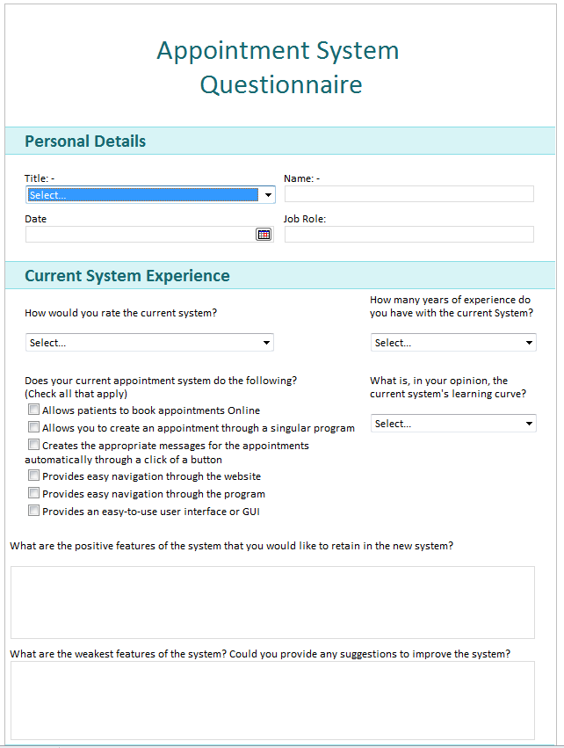
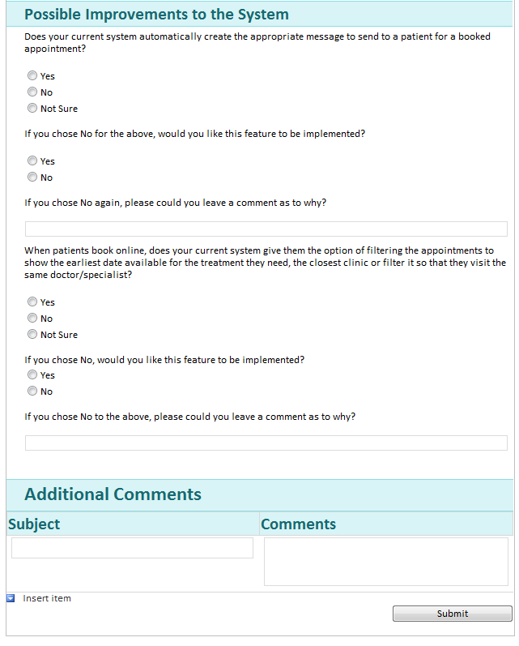
Above is a questionnaire which will be filled in online and send the results back to me through my email address. I made this to find out more about what my end users think of the current system and find out what they would want the new system to do.

Filled-in Questionnaire

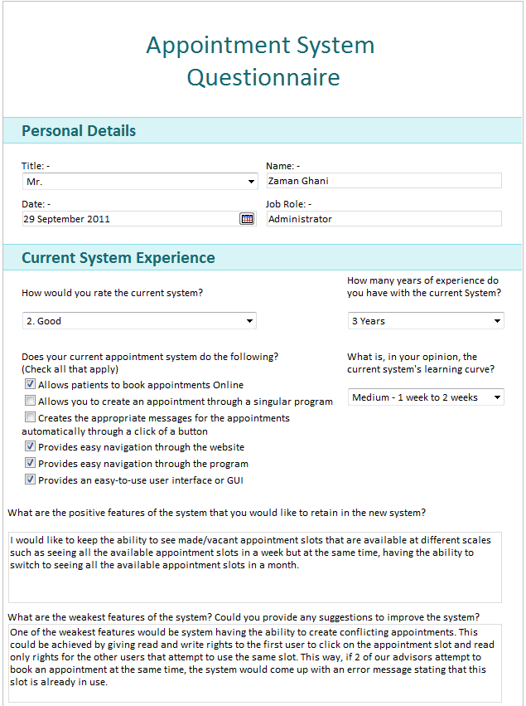

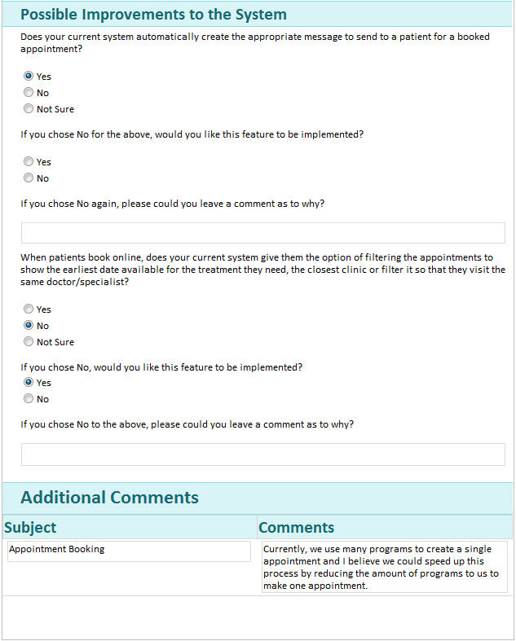

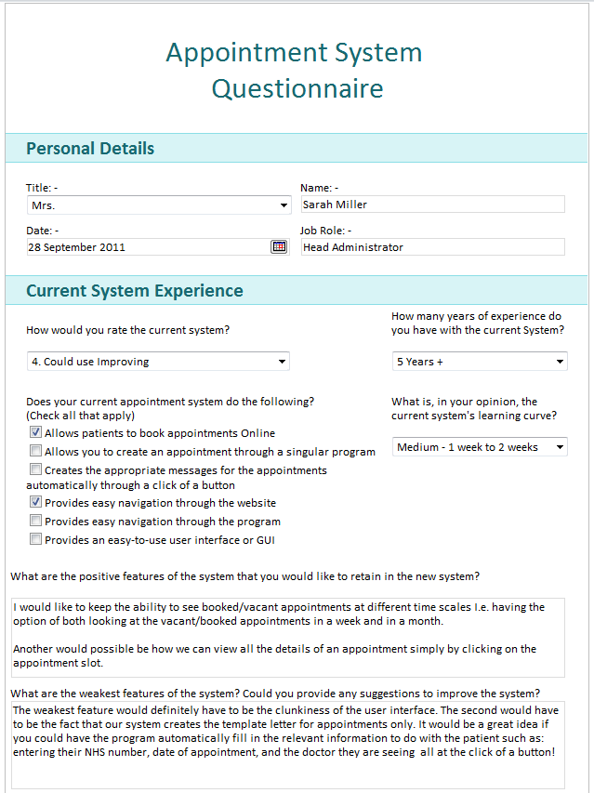

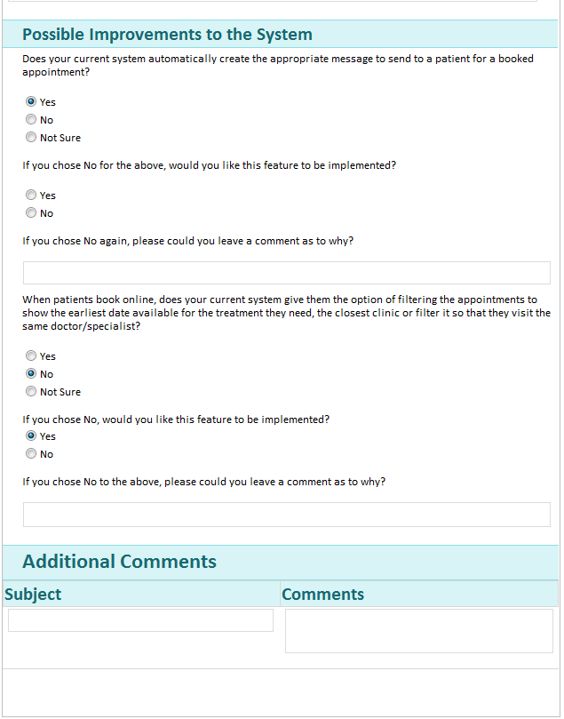

Examining Existing Documents
Displays the number of free slots available for that specialist/clinic
Colour coded appointment legend. This could be used to sort the appointments which need to be urgently taken care of.
This calendar is used for quick referencing to appointments on certain dates.

Filter available in the system to make it easier to book an appointment where the patient requires a specific treatment.

This is a weekly timetable format. The red “x” on the corner of an appointment signifies that the patient did not attend or the service cancelled the appointment or that the patient cancelled the appointment. An option to print is also given.

Clinics/Specialists/Doctors listed here. The acronym in brackets represents the location. Click on one of these will produce a timetable for that specialist/ clinic/hospital.

Time periods of appointments show where the rectangle boxes to the left hand side show that the appointment is booked and gives patients details and short description of problem

Free to choose to what time scale vacant appointments are shown on.
Below is a 50-day overview of the vacant appointments. Clicking on a little numbered box will bring details of the vacant appointments available. You can once again filter the speciality
Name of specialist

Total at Row column shows total vacant appointments in 50 days where as the column total shows appointments available in a day

Name of treatment type (colour coded again just like the numbered vacant slots)

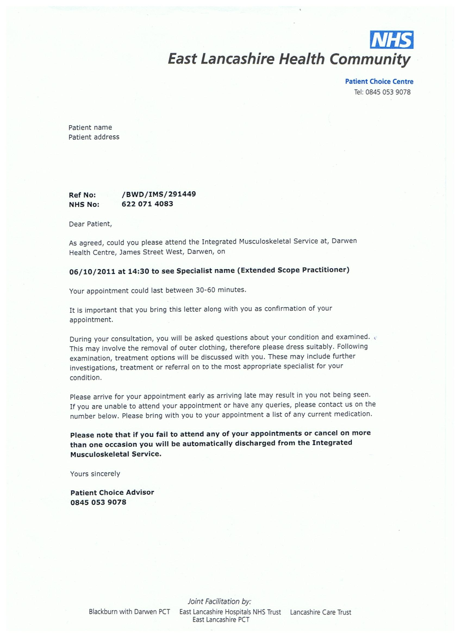
This letter contains the location, date and time of the appointment along with the specialists name and the treatment they are going for.
An approximation of the time duration is given and an introduction about what will happen is also given.
Consequences of failing to attend are also sent to patient and the letter is signed by the Patient Choice Advisor.
Clearly visible below the NHS logo is the “Patient Choice Centre” number.
Letter addressed to patient including their name and address
Each person is given a reference No.
Also listed is the unique NHS No.
This is one of the many different letters that can be sent out. This is the letter sent out for those who have booked an appointment for the first time.

Description of Current System

Analysis of All Documentation
By analysing all the documentation, I have surmised the following:
Concerning what should be kept the same:
Through both interviewing and using the questionnaire, it became clear that the main aspect that my end users wanted to retain was the ability to view booked/vacant appointments. This could be done by creating a report which functions which can be filtered. A function could also be added to check if the dates of appointments do not conflict with other dates and times for a specific clinic.
This leads me to the conclusion that my end users enjoy having the choice of looking at a detailed overview.
Concerning what could be improved:
I reached the conclusion that both my end users want to greatly reduce the time spent on completing appointment requests. My reason for this is that both my end users have commented on the fact that they would like the system to compile all the appointments they have made for a day and then create the relevant letter for each appointment with all the information already filled in (information such as patient’s name, location of appointment, date of appointment etc.)
Furthermore, one of my end users stated that he would like the system made such that conflicting appointments should never be a problem. Doing this would increase the speed at which appointment requests are made as they would not have to phone back the patient(s) to decide on a new date for the appointment(s).
Looking at the existing documentation:
By looking specifically at the existing documents, I have found that the option of filtering results is crucial as it eases the task of manipulating appointments. In addition, the option of change the time scale of the appointment booking system will assist in making booking appointments an easier task as you can see if there are future appointment slots available.
Furthermore, it is vital that patients be told of the consequences of failing to attend an appointment as this will cost the NHS time and money.

How the Existing System is Run
- An appointment is made by following on the 3 ways listed below:
The GP sends a reference to the Hospital describing the patient’s medical problem along with the patient’s personal details and past medical history (PMH)
The patient can book online through the website.
The patient will have to ring a telephone call centre called “Patients Choice Centre”. They will then confirm the patient’s details and give a password to login online to check their appointment.
- The “Patient Choice Centre” receives the information.
- The centre phones the patient to verify this information
The patient is phoned and made to verify their name, address, date of birth, NHS number and a short description of their problem along with the GP they have seen.
- An appointment date is agreed to by the advisor and the patient.
The advisor phones the patient and they discuss the possible dates for the appointments, the location of the clinic/hospital and the best time for the appointment and the advisor. They are also asked if this is their first time going for a treatment. The advisor then gives them their reference number and password from which they can log in online to view their appointment details and date.
- The information is then put onto the system and takes up a vacant appointment slot.
The information is then registered into the system. Sometimes, a new patient profile must be created as they are going to the hospital/clinic for the first time. In the cases where the patient has an existing profile, the appointment slot is simply linked to the patients profile through the use of the NHS number.
- A letter is sent out to the patient.
If it is the first time they are having the treatment, a description of what will happen at their appointment will be stated as well as the consequences of failing to attend.
- A reminder is sent prior to the date of the appointment.
A small reminder card is sent to notify the patient of the upcoming appointment date and time.
- The system is then updated to show whether the treatment has started, finished, or has been cancelled.
A cross inside a circle represents that the appointment service cancelled the appointment or that the appointment was cancelled by the patient or that the appointment did not attend. The reason is specified when you click on the appointment slot to bring up details of the appointment. The letter “T” inside the circle represents that the treatment has started.

Problems in the Existing System

Conflicting Appointments
One problem is that appointments can conflict when 2 or more patients talk to their advisors and agree to book on an appointment. This appointment, however, is also agreed to by 1 or more patients. Therefore, we are presented with the problem of having 2 or more people attending an appointment at the same time and place and with the same doctor/specialist. This could be solved by giving read and write rights to the first user that access’s an appointment slot and the subsequent users that attempt to do the same get an error message stating that the appointment slot is already in use.
Tediousness of creating one letter at a time
Creating one letter at a time for an appointment and filling out the information that isn’t done by the system is quite tedious. This could be improved through the use of a button you press which compiles the appointments which have been created on that day and then creates the relevant letter for each appointment through the use of keywords/giving them appropriate Meta tag. The information for specific details such as: location of clinic, appointment time etc. could be fetched from the system and thereby already complete the process of creating the letters for you.
Lack of a Search Function
The current system lacks a search function and such, navigating through the system is tedious. To resolve this problem, an advanced search function could be created which allows either a single search function or multi search function where the user could determine what fields the user wishes to search by. This would greatly reduce the time in finding a specific record.

Identification of the User(s) Needs and Acceptable Limitations

Features of the New System
The end users have requested that the new appointment system should contain the following:
- A Login Function
The login function should provide security to the booking system so it cannot be jeopardised in any way. The login function is also use to provide administrators and specialists/doctors adequate rights to their job role. This includes an advanced validation check for valid ID checking through the use of a specially created algorithm.
- Create user
Bundles with the package of a login function, is the function that allows you to create more accounts that have different system access rights
- An Appointment System
- Avoid Double Booking
A grievance that the end users had with the current system is that you could double book an appointment. One feature of the new system is to eliminate this possibility.
- Streamlined Appointment booking

Produce Appointment Letters
The new system must be able to produce appointment letters for each and every appointment and must be able to create letters by filling in the blanks of a template letter by using the information stored in the appointment record. To streamline the process, the appropriate letter should be generated from a single mouse click.
Produce Appointment Letters Labels
The new system must be able to produce letter labels for each letter which can be printed off
- Informing the Doctor about the Appointments
The new system must be able to reference each appointment onto the relevant doctor’s timetable so that doctors can simply select an appointment time box and it would bring up a detailed information box about the patient and what their medical problem is.

- Provide Patient Summary Records
The system must be able to produce a summary of a patient’s record which is available to the doctor.
- Contact with Patients
The appointment system must be able to produce an initial letter to inform the patients about the details of their first appointment and what will happen in their initial appointment.
The system must also be able to produce both reminders and emails to promptly notify the patients of an upcoming appointment. In addition to this, the system must be able to deal with the non-attendance of the patient and update the relevant records as well as create a letter to notify the patient of the consequences of not attending the appointment. Follow up appointments must also be dealt with in a similar manner where another appointment record is updated and a letter is to be created to notify the patient of the follow-up appointment.
- Search Function
The end users would like to have a search function installed onto their new appointment system which would allow for search filtering. The search function should be able to search for the patient’s profiles through the use of their NHS number and a similar function should be available to search for specialists and doctors. Searching for clinics and hospitals can also be done by typing the location of the clinics.
- Field Validation Function
To save future trouble for the end users, I must produce a system where all the fields must be validated once data has been entered. If the data is not valid, then the system produces an error message and prevents the user from changing any other fields until the invalid data has been changed into valid data
- Backup Function
The system needs to have a rigid backup function as the system will come under heavy load due to 100’s of patients booking appointments every week. The backup function has to create a separate folder for every backup.
- Preventing booking an appointment on a date when a doctor/doctors is/are on holiday
The system should be coded such that it is impossible for a scenario to occur where a patient has booked an appointment on da date when no doctors will be in.

Agreed and Acceptable Limitations of the New System
After discussing the features of the new system with my end users, we also devised a list of acceptable limitations for the new system.
Viewable online map of departments
This system will not be able to make an online map of all the departments as this will cost precious time which could be used on making other improvements to the system. Furthermore, maps of departments are available either on the websites of the clinics/hospitals or are available once you enter a clinic/hospital.

Ability to locate nearest clinic and give directions
Again, this would cost too much time and effort to build. Furthermore, we assume that the patient knows some information about his or her area such that they can make a decision of going to their closest clinic or hospital which offers treatment. In addition, as we assume that the patient knows some of the area which they live in, they may know the directions to the clinic/hospital or if they do not know the directions to the clinic/hospital, they could use an available online system which could help them find their way I. E. Google maps.

A Graphic Timetable Interface
This graphic timetable would take too long to set up in the time available as it needs many advanced features. It would also have to work like the previous graphical timetable where all the information about the appointment is available simply by clicking on the relevant appointment slot.
The advanced features would include tailoring the view of the timetable to suit the user(s) need which would take too long to complete in the time available.
To circumvent this, a timetable will still be created but it will not be graphical.

Data Sources and Destinations
Below I am going to list each “Action/Data Item”, their source and their destination.
Action/Data Item | Source | Destination
Patients Details | GP supplies name, address, birthdate, known allergies, NHS number, phone number, gender, Disabilities (current medication?) of the patient. The patient verifies the details. | Stored in a secure database and the patients records are identified by the NHS numbers alone.
Clinics Details | Clinic supplies location, their speciality, their opening hours/days of the week, contact information | Stored in a database and is identified by the full name of the clinic
Doctors Details | Provided by the doctor who supplies his or her name, speciality, which clinic they work in, timetable which shows working hours, breaks and holidays booked in advance. | Stored in a database and each record is identifiable by the doctors
Making Appointments | GP supplies information about a patient’s medical problem(s) and sends a reference to the clinic or GP could refer you through the online booking system or can give the patient an appointment request form to fill out. | Details of the patient’s problem are recorded and attached to the patient’s record which has their unique NHS number.
Cancelling Appointments | Patient requests to cancel the appointment. NHS number and date of appointment is supplied by patient. | Details of the appointment are temporarily put in the “Cancelled Appointments Log (CAL)” as the data of the appointment is removed from the actual system.
Checking for “Did Not Attend (DNA)” Appointments | Scanning the appointment logs for appointments with past dates where the field “Attended” is not ticked. Patients NHS number and contact information is recorded. | Details go temporarily into the “Did Not Attend (DNA)” log.  A letter is sent to the patient stating they have been discharged from the service.
Letter for Patient’s First Appointment | Data used includes: patient’s full name, NHS number address; clinics name and location and appointment time and date.  Information about first appointment | Creates a letter with information about first appointment and is sent to the patient
Letter for Patient’s Follow-up Appointments | Data used includes: patient’s full name, NHS number address; clinics name and location and appointment time and date.  Information about follow up appointment | Creates a letter with information about a follow-up appointment and is sent to the patient.
Letter for Patient’s who Failed to Attend | Data used includes: patient’s full name, NHS number address; clinics name and location and appointment time and date.  Information about consequence of failing to attend | Creates a letter with information about the patient being discharged from the service that they made an appointment for and is sent to the patient.
Letter for Clinic/Service Cancelling Patient’s Appointment | Data used includes :patient’s full name, NHS number address; clinics name and location and appointment time and date  Information about why appointment was cancelled. | Creates a letter with information about why the appointment was cancelled and is sent to the patient.
Appointment Reminder Card /Email Sent Out | Data for reminder includes: patient’s full name, NHS number address; clinics name and location and appointment time and date | A reminder card and an email is created and sent to the patient using the information of the appointment.

Data Volumes
Due to a time constraint, I will be limiting the program to only accommodate 20 clinics.
Clinics - The existing system accommodates approximately 1000 clinic records. My system will be storing 200 records of clinics due to constraints.
Each clinic’s record will consist of a table of information with approximately 10 fields. This data will be most likely stored for many years and would only need updating every so often.
Approximately each record will take up 175 bytes. So Approx. space taken is
50x 175 =8750 = 8.75 kb
Patients - The existing system stores approximately 200,000 patient records. My system will be accommodating 500 due to restraints.
Each patient’s record will contain a table of information with approximately 14 fields. This information will need to be kept for many years; however, it may need to be updated more frequently than that of the clinic’s records.
Approximately each record will take up 300 bytes. So Approx. space taken is
500x 300 = 150kb
Doctors - The existing system stores approximately 50,000 doctor records. My system will be storing 50 doctor records due to constraints.
Each doctor’s record will consist of approximately 6 fields and the information will need to be kept for many years. This information will not need updating much however.
Approximately each record will take up 100 bytes. So Approx. space taken is
50x 100 = 5kb
Appointments – There are approximately 50,000 appointment records stored in the system. My system will store approximately 100 due to constraints.
Each appointment records will need approximately 5 or 6 fields of information which will need to be kept until around 1 week after the appointment has ended. Therefore, the time for which the appointment information is stored could vary from days to weeks to months or a year.
Approximately each record will take up 175 bytes. So Approx. space taken is
100x 275 = 27500 approx. 27.5kb
In total approximation without space taken up by images and etc., the system should be a file size of 191.25kb.

Analysis Data Dictionary
Below is a dictionary of all the “Data Items” I will be using in my program.
Included are data items necessary for the PMR (Personal Medical Record), patient records and more.
Data Item | Purpose
Forename | Used to identify a person
Surname | Used to identify a person
Gender | Used to identify gender specific health problems and regulate gender specific medication.
Date of Birth (D.O.B) | Used to restrict certain medication with an age limit or restricting operations with an age limit
Address | Used to contact a person
Postcode | Used to contact a person
Town/City | Used to contact a person
Phone Number | Used to contact a person
Mobile Number | Used to contact a person
Email Address | Used to contact a person
NHS Number | Used to uniquely identify each patient’s record
Known Allergies | Used to restrict certain medication which people are allergic too.
Emergency Contact | Used for contacting a person in case of an emergency.
Date of Latest Physical Exam | Used to check if a patient needs another physical examination due to an injury
Past Tests and Screenings | Used to establish what a patient has previously been tested/screened for
Dates of Past Tests and Screenings | Used to identify the date of a patients latest test/screening and to decide if a patient needs another test/screening
Results of Tests and Screenings | Used to establish if the patient has been diagnosed with any problems
Past Major Illnesses | Used to verify if a current illness/medical problem may be caused by a past illness.
Past Surgeries | Used to identify whether or not a medical problem has been resolved
Past Surgeries Dates | Used to verify if a patient has recovered from the operation such that it does not interfere with any other medical practice.
Past injuries Had/Treated For | Used to determine which injuries a person has sustained/been treated for and if they have recovered from those injuries.
Past Medicine Use | Used to determine which medication a patient has taken and regulate which medication a patient cannot take other medication due to this.
Medicine Dosage | Used to ascertain the strength of the medication used by a patient and whether this will effect operations or the effect of other medication.
Time Length of Medicine Usage | Used determine if a patient can have an operation/use a certain medicine or if it will conflict with what the patient is currently taking.
Known Chronic Diseases | Used to establish if a patient is suffering from a new medical problem or whether the problem is chronic
Genetic Illnesses | Used to check if a person has an illness that runs through the family or is something completely new
Blood Type | Used to regulate what blood a patient can’t receive.
Disabilities | Used to identify if there needs to be any accommodations for the patient’s disability i.e. sign language interpreter, large print etc.
Current Doctor/GP | Used to contact a patients GP
Speciality | Used to establish what the doctor and/or clinic specializes in.
Works for Clinic (i.e. Doctor Works for Clinic) | Used to determine which clinic a doctor works for so that they can easily be contacted.
Working Hours in a Week | Used to establish if a clinic/specific doctor can cover a certain appointment time.
Booked Holiday Dates | Used to determine when specific doctors will be unavailable.
Name of Clinic | Used to identify the clinic.
Opening Hours | Used to determine whether or not an appointment can be made for a patient at a specific time.
Days Available | Used to determine whether or not an appointment can be made for a patient on a specific
Fax Number | Used to contact a clinic/hospital.
Appointment Date | Used to determine what date an appointment is supposed to take place at.
Appointment Time | Used to determine what time an appointment is supposed to take place at.
First Appointment | Used to establish if the patient is attending the first appointment or not and the correct procedures are carried out for both circumstances

Data Flow Diagrams of the Existing System
NHS number, date and time of appointment and name of preferred clinic and date and time of appointment
Patient NHS number, PMH, Contact Details, Reference Letter etc
Phone Patient’s Choice Centre
Email or Phone Centre or Book Online
Patient
GP Sends Reference/ Books Appointment Online

Patient NHS number, PMH, Contact Details, Reference Letter etc
NHS number, date and time of appointment and name of preferred clinic and date and time of appointment
Verify details, appointment date & time available for clinic and doctor
Patient’s Choice Centre
Online Booking System

Patient’s Record
Updates Patient Details/ New Patient Record
Sends patient’s details if available
Date, Time, Clinic name, patient NHS number, Doctor Name
Verify if first appointment. If it is, it creates details for patient
Clinic open time, clinic name

Doctor’s operating hours & Name
Clinic’s Record
Date, Time, Clinic name, patient NHS number, Doctor Name
Doctor’s Record
Appointment Details
Create Appointment
Appointments Record
Appointment details
Appointment details
Patient’s details
Doctor
Appointment details
Letter
Create follow up appointment letter
Create first appointment letter if applicable.
Letter
Patient

Appointment details
Letter
Verify patient attended appointment
Appointments Record
If DNA, Create “Did not Attend” appointment letter
Patient’s details

Entity-Relationship Model and Entity Descriptions

Clinics can have many appointments and therefore, many patients. They can also employ many doctors and therefore have a one-to-many relationship with all three other entities.
Doctors can also have many patients so they have a one-to-many relationship. They can also have many appointments, but at the same time, appointments can have many doctors so that is a many-to-many relationship. However, Doctors cannot have many clinics as they can only work in one clinic.
Patients can have many appointments but cannot have many clinics as patients are assigned a single clinic in an appointment. They, however, can have many doctors in an appointment as different doctors may be required for different procedures. This means that doctors and patients have a many-to-many relationship

Patient
Appointment
Clinic
Doctor

Realistic Appraisal of the Feasibility of Potential Solutions

There are a number of ways in which a new system could be created for the end user. Below I will list and explain each potential solution.

Improving the Existing Manual System
Cost: - The cost of improving the existing system wouldn’t be as large as the cost for creating an entirely new system. The idea is to tweak the existing system so I believe no additional software or hardware would be necessary for this process.
Ease of Implementation: - In terms of ease of Implementation, I believe that it would be quite easy to implement as the actually system is already there and the idea is to simply tweak the current system such that it fulfils the end user’s requirements and therefore only a small amount of work needs to be done
Ease of Use: - The ease of use of the improved system I believe would be very high meaning it would be really easy to use as the end users are already familiar with the current system and only need to adapt to the new functions of the system available to them.
Functionality: - I believe that an improved existing system would have a substantial increase in its functionality as the system itself has been tweaked so it able to perform more tasks which weren’t possible before. Also, since the existing system was already catered to perform the tasks required by the end users, simply improving would increase its functionality too as what you are doing is essentially further tailoring the system to meet the end user’s needs.
Resource Requirements: - The amount of resource requirements for improving the existing system, I believe, will be minimal as you are merely improving the existing system so the resource requirements of the improved system will be very similar to that of the old system and only if drastic improvements were made would we see a substantial difference in the resource requirements of the improved system and the old system. Therefore, I believe that no additional software or hardware will be needed to improve the existing system unless a complete or close to complete overhaul of the system was done.
Time to Produce: - The time to produce an improvement of the existing system I believe wouldn’t be as long as the time to re-write a whole new system from scratch. However, the time to improve a system to the point it fulfils most, if not all the end user’s requirements is significant enough to warrant it being a downfall or disadvantage of using this method.
Technical Support Available: - The technical support available if the existing system were to be improved is limited because if a lot changed in the improved system then only I would fully be able to resolve any technical difficulties the end users may encounter. If however the changes are not as significant, it could be possible that they too could solve their own technical difficulties due to end users already having experience using the pre-improved system.

Buying a Package Specifically Written for an Appointment System
Cost: - After reviewing numerous appointment system software packages and making sure they would meet the criteria proposed by my end users, the cost of buying a simple package with limited features ranged from £30-£50 or had a monthly cost associated to it such as £4.99 a month. For packages with a greater amount of functionality, the cost ranged from anywhere from £60-£120 and for those which used a subscription based financial model, they cost £15-£20 a month or £150-£200 a year.
Ease of Implementation: - I believe implementing a pre-written package would be quite easy in terms of installing it onto a computer system. However, some tailoring may still need to be done to meet the specific needs of the end users.
Ease of Use: - The ease of use of a newly bought package would be very low i.e. it would not be very easy to use as the end users need to first off learn how the entire system works before they can begin to carry out their tasks.
Functionality: - The functionality of a bought package even when specifically written for an appointment system in mind is fairly limited due to the fact it is not catered to the end users absolute requirements which I consider highly important. However, I believe that the package would be able to carry out most tasks which my end users specify.
Resource Requirements: - The resource requirements of installing a bought package I believe would be very small if not negligible as the packages I have researched do not require any additional hardware or software to be bought for the package to perform its designated tasks.
Time to Produce: - The time to buy and install a specifically written package would be very small and is one of the major advantages of using this method to provide a solution for my end users.
Technical Support Available: - One large benefit of buying a specifically written package is that a lot more technical support would be available if the package was to be bought from a known software developing company. Therefore, technical support would be largely available.

Customizing a General Purpose Database
Cost: - The cost of using a general purpose database would be significant as you would first have to buy the software that allows you to create a database or manage a database such as Microsoft’s “Access”. Then it would cost time to tailor the general purpose program to meet the end user’s requirements.
Ease of Implementation: - It would not be very easy to implement as you would still need to tailor the database to meet the end user’s specifications.
Ease of Use: - I believe that end users would find that using a general purpose database would be very easy to use as the software is made in the mind-set that the program has to have an easy to use interface and that documentation is always there to help those who find it confusing.
Functionality: - The functionality of a general purpose database I would believe to be one of the most limited even after customization as it was essentially designed for a general purpose and not a specific purpose which my end users are looking for.
Resource Requirements: - The resource requirements for using a general purpose database would be very low as they do not need any additional software or hardware to function.
Time to Produce: - The time to produce a customized general purpose diagram would not be as long as creating the software from scratch as you are simply customizing some pre-built software.
Technical Support Available: - Large amounts of technical support will be available for a general purpose database as they normally come with documentation to help the end users use the software. I do not think the technical support available will differ much even after customizing the software.

Writing a Program Using Visual Basic
Cost: - The cost of writing a program using visual basic would include the cost of buying the software to write in visual basic and then it would cost a lot of time to write a program tailored to the end user’s requests starting from essentially nothing.
Ease of Implementation: - Implementing the program would not be very easy as a lot of tailoring would need to be done as this system is being built from essentially nothing.
Ease of Use: - I believe that using that end users would find the program quite easy to use as they have a more direct say in what the program is built to do. This means that they already would have an understanding of what each specific function of the program would do which would make using the program very easy.
Functionality: - The functionality of creating a program using visual basic would only be limited by the limitations created by the code. Also, as the program is being created from the very beginning, the program could be tailored such that it fulfils most if not all of the requests of the end users. The only requests it may not be able to fulfil are those restricted by the limitations of the programming language.
Resource Requirements: - No additional hardware or software would need to be purchased outside of purchasing the visual basic software itself. This results in a small resource requirement for using this method.
Time to Produce: - The time to produce a completely functional program from essentially nothing is a substantial amount and is the main disadvantage of using this method to create a new system for the end users.
Technical Support Available: - Technical support would be very limited as well as only I would be creating the system independently which in effect results in only me being able to provide technical support for the program.

Writing a Program that is a Combination of Access and Visual Basic
Cost: - The cost would include purchasing both “Access” and the software to write visual basic would be significant with the addition of the amount of time it would cost to write the program from nothing.
Ease of Implementation: - Implementing the program would not be very easy using this method as, again, a lot of catering would need to be done so that the program would meet the end user’s requirements.
Ease of Use: - I believe that the program would be quite easy to use as the end users again would have a direct say of what they want the program to specifically do. This would make using the program easy as they would already have a general idea of what all the functions would do when the program is complete
Functionality: - The functionality of this program is merely limited by the limits of both access and visual basic as the system could easily be designed such that it would meet all of the end user’s specification except those which are not possible due to the software we have used to create the program or the language we have used to create the program. However, I believe that his program would have the greatest functionality as it would have both the functions of access and the functions possible through visual basic coupled with the fact that this program can be designed such that it can create all functions except those that are restrained by the limitations of both the programming language visual basic and access.
Resource Requirements: - No additional hardware or software would need to be purchased outside of purchasing the visual basic software and access.
Time to Produce: - Again, the time to produce a program form nothing would be substantial but would not be as high as that of creating the program using visual basic alone as I have both the functions of visual basic and access available to me which gives me more versatility and therefore could quicken the production time of the program.
Technical Support Available: - Technical support would be very limited as only I would be able to fully debug the program as I alone would make it.

Potential Solutions Summary
Key:
Cost: 1 = Cheapest; 5 = Expensive Ease of Implementation: 1 = Easiest; 5 = Hardest
Ease of Use: 1 = Most Helpful; 5 = Least Helpful
Functionality: 1 = Fulfils all objectives; 5 = Minimal objectives fulfilled
Resource Requirements: 1 = Can be implemented; 5 = requires lots of resources
Time to produce: 1 = Fastest; 5 = Slowest
Technical Support Available: 1 = Most support available; 5 = Least support available

Method | Cost | Ease of Implementation | Ease of Use | Functionality | Resource Requirements | Time to Produce | Technical Support Available
Improving the Manual System | 1 | 1 | 1 | 3 | 1 | 2 | 3
Purchasing Off-the-Shelf system | 3 | 2 | 2 | 5 | 3 | 1 | 1
Customizing a general purpose database | 2 | 3 | 3 | 4 | 2 | 3 | 2
Writing a program in Visual Basic | 4 | 5 | 5 | 2 | 4 | 5 | 5
Writing a program that is a combination of Access and Visual Basic | 5 | 4 | 4 | 1 | 5 | 4 | 4

Improving the Manual System total = 12
Purchasing Off-the-Shelf system total = 17
Customizing a general purpose database total = 19
Writing a program in Visual Basic total = 30
Writing a program that is a combination of Access and Visual Basic total = 27

Justification of a Chosen System

From the totals, the best idea would be to improve the manual system; however, I will be choosing to write a program that is a combination of Access and Visual Basic as it offers a greater functionality which is what my end users are really looking for.
In addition, the cost of writing a program using a combination of Access and Visual Basic is very small as I already possess the necessary software and therefore, the remaining cost would be the time it would take to write this program from essentially nothing.
Although this method also requires the greatest amount of resources, my end users already have access to both Visual Basic and Access at their workplace meaning the resource requirements are already met.

The program designed using this method may have limited technical support, however, I intend to design the program such that it has an easy to use and understand interface and I will also be creating a manual to further assist the end users if they do run into any difficulties when using the program.

The time to produce the program may be long, however, I have been given sufficient time such that I will be able to meet most if not all the requirements of my end users using this method.

In conclusion, by using this method, I will not have the disadvantage of this method being the most expensive as I already have the necessary tools at my disposal and the amount of time Also I have been given to write the program is good enough such that I can meet most if not all of the criteria listed by the end users. Therefore, by using this method, I can create the most functional program for my end users which to them are their most valued aspect when looking to create a new system.

General and Specific Objectives
General objective(s):
The new system will add extra security than the previous system as well as being able to maintain and process data more easily through the use of a relation database. The program will also streamline the appointment making process as well as preventing incorrect data from being entered through rigorous amounts of validation.
Specific objective(s):
- Allows the admins to add/edit/delete patient records
- Allows the admins to add/edit/delete clinic records
- Allows the admins to add/edit/delete doctor records
- Allows the admins to add/edit/delete appointment records
- Allows the admins to add/edit/delete medical records
- Allows the admins to add/edit/delete past medicine usage records
- Allows the admins to add/edit/delete past test results records
- Allows the admins to create regular backups of the files they specify through click of a button
- Allows the admins to add or change rights of other non-admin accounts
- Sets up validation rules for every field to ensure only valid data is entered
- Allows appointments times and dates to be rigorously checked if they conflict with other appointment times and dates.
- Sets up a one-button system which generates the appropriate letter for the appropriate appointment type to streamline appointment making process
- Creates overviews which allow for easy manual record search needs
- Allows the users to utilize the single search and multisearch functions to streamline data the data gathering process
- Enhances security by adding an extra layer of protection through the use of a security code which all users must enter. This prevents unauthorized access into the system if the transgressor has managed to find a valid username and password combination.
- Allow doctors to see appointments which they must attend through the use of a timetable
- Prevent appointments to be made for a clinic at a date when no doctors are available.
- Create a summary sheet to show the patient to doctor ratio and more.
- Allow users to sort records though a multitude of fields
- Allow labels to be printed off to see off with appointment letters

